**Instruction to deploy and run code**

**Instruction to run code**

* Download and install R and Rstudio from this link: https://rstudio.com/products/rstudio/download/
* Download the suitable version according to the system requirements

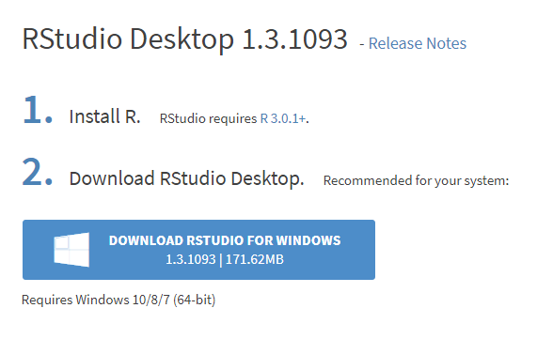

* After installing Rstudio, open the Command Prompt.

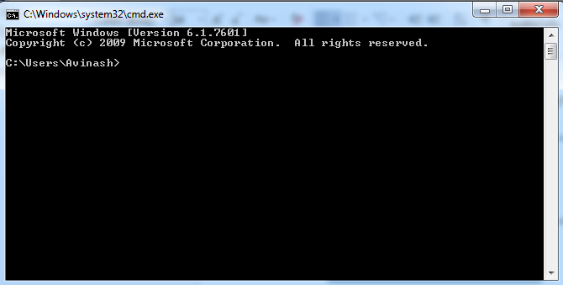

* Navigate to the directory where R code is saved. Then type filename (Bank_Loan_Default-R.R).   
    
  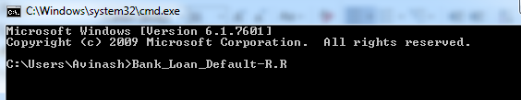
* RStudio will immediately pop up and open the R code saved in the current directory.  
  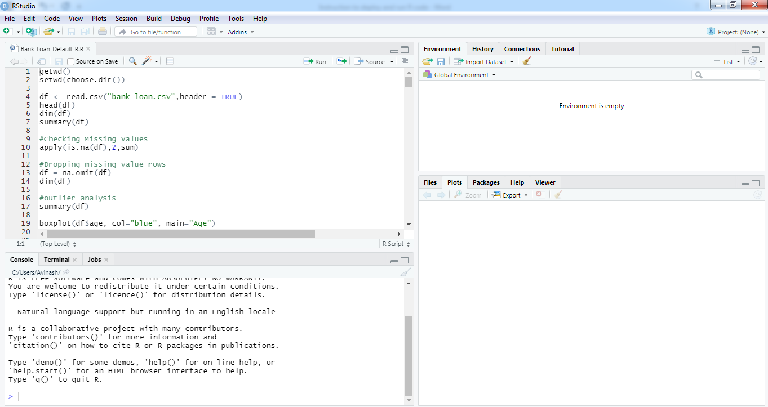

* To run the R code, click on the ‘Run’ and select ‘Source’ in the toolbar.  
  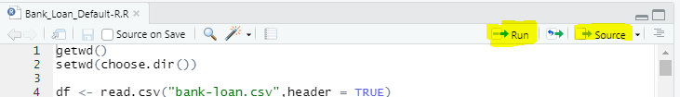

* The code will run now.

**Instruction to deploy the model**

* Here are the instructions to deploy the model in Heroku using Shiny.
* Shiny is an R package that makes it easy to build interactive web apps straight from R
* Create app for the bank loan default prediction model. It consists of 2 parts. User Interface and Server.

User Interface:  
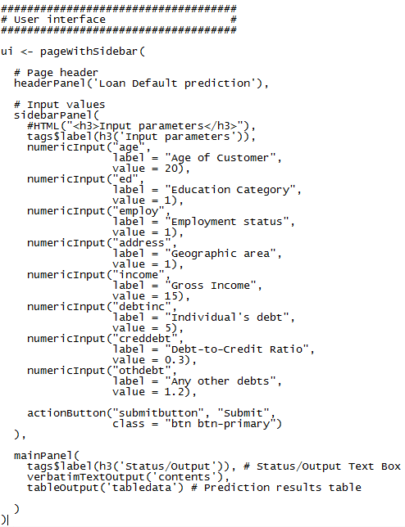

Server:  
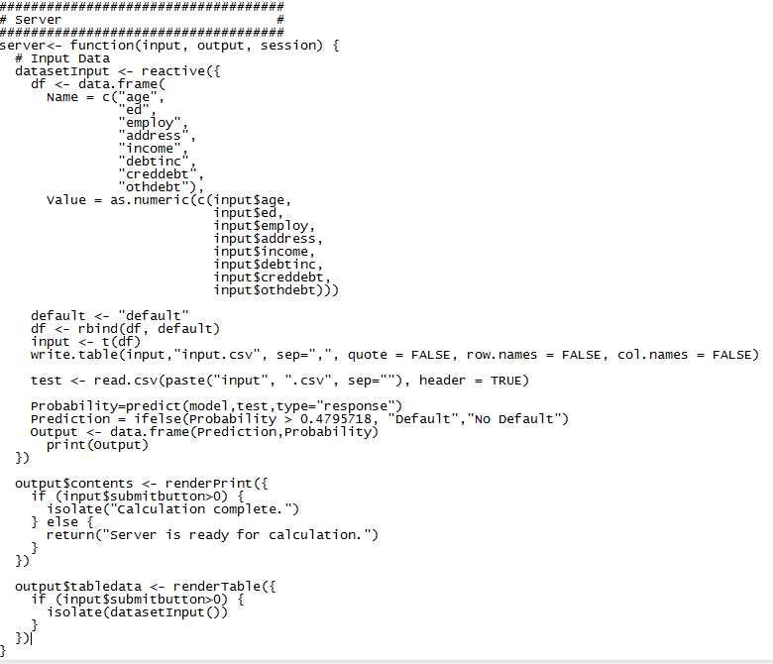

* Save the user interface and server as app as ui.R and server.R respectively
* Now that we have our application we are ready to start deploying the application to Heroku.
* Create a Git repository in the same directory where the files are saved. A Git repository can be created with **git init**.

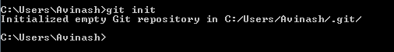

* Create a Heroku Account: https://signup.heroku.com/
* Install the Heroku Command Line Interface (CLI): <https://devcenter.heroku.com/articles/getting-started-with-python#set-up>
* Login to Heroku



* Deploy the Application: Deploy application to heroku by running heroku create to create an Heroku instance.



* Heroku doesn’t have buildpack that suports R. So we need to provide buildpack when creating application on Heroku.  
    
  **heroku create --buildpack https://github.com/virtualstaticvoid/heroku-buildpack-r.git**
* The buildpack will detect application makes use of R if it has the following files in the project directory:  
  **init.R**:  
    
  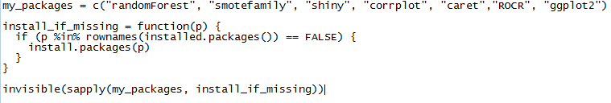  
    
  **run.R**:  
    
  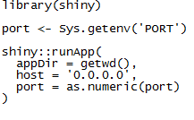
* Push the code to that instance using the following commands.

**git add .**

**git commit -m "bank default"**

**git push heroku master**

* It should automatically detect that you have a shiny app and it should install all packages inside the init.R.
* Check if the application was deployed successfully using **heroku ps:scale web=1**.
* The application can be opened with ‘**heroku open’**. This will open the app using the default browser.

App deployed: https://bank-loan-default-rcode.herokuapp.com/

Github repository: https://github.com/avinashsajeevan/Bank-Loan-Default-Prediction--R

